Rj45 to M12 D-code data cable

Using cat 5E 4twp cable

The intent of this cable is to adapt or communicate with over Ethernet protocol. You still be will be producing wither a male or female m12 plug to a cable that has an rj45 plug on the other end.

Parts

1. One of the following.
   1. Male M12 4 position D-coded plug digikey pn xxxxxxxxxx
   2. Female M12 4 position D-coded plug digikey pn xxxxxxxxxx
2. Cat 5E or cat 6 cable with 4 twisted pairs
3. Rj45 plug PN xxxxxxxxxx or trimet pn xxx-xxxxX
4. Rj45 plug stress reliever

Assembly

1. Assemble one end of the cat cable using an RJ45 jack and using the T-568B scheme
2. Depending on the type of cable use ferrules on braided wire and none on solid copper wire.
3. Wire the other end of the cable to the M12 plug as shown in the reference material

Overall Pinout

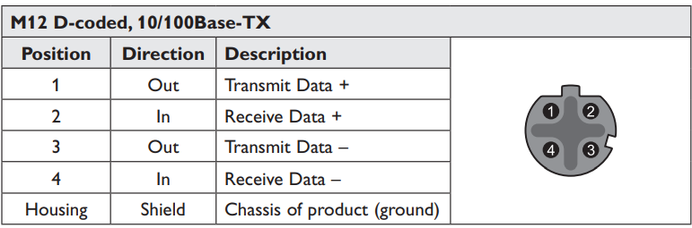M12 wire color RJ45

1 OR/WH 1

2 Orange 2

3 GR/WH 3

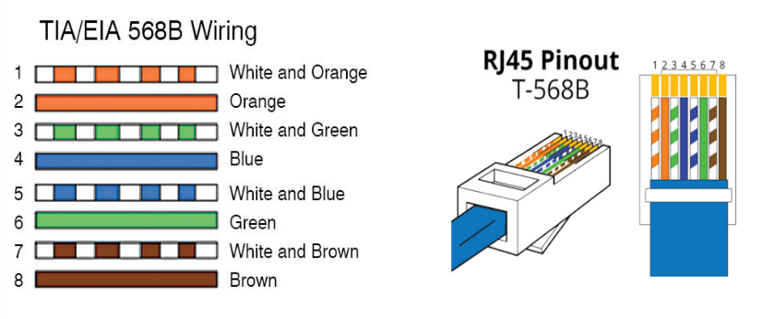6 Green 6